Week 2 – 1:

--Operators and Expressions, Managing Input and Output Opearations

ROLL NO.:241501060

Name: Gowtham P

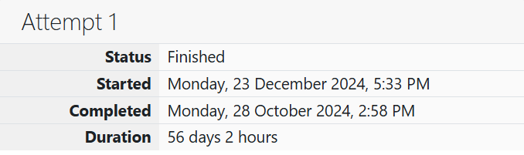

**Q1)** Many people think about their height in feet and inches, even in some countries that

primarily use the metric system. Write a program that reads a number of feet from the

user, followed by a number of inches. Once these values are read, your program should

compute and display the equivalent number of centimeters.

Hint: One foot is 12 inches. One inch is 2.54 centimeters.

**Input Format**

First line, read the number of feet.

Second line, read the number of inches.

**Output Format**

In one line print the height in centimeters.

Note: All of the values should be displayed using two decimal places.

**Sample Input 1**

5

6

**Sample Output 1**

167.64

Code:

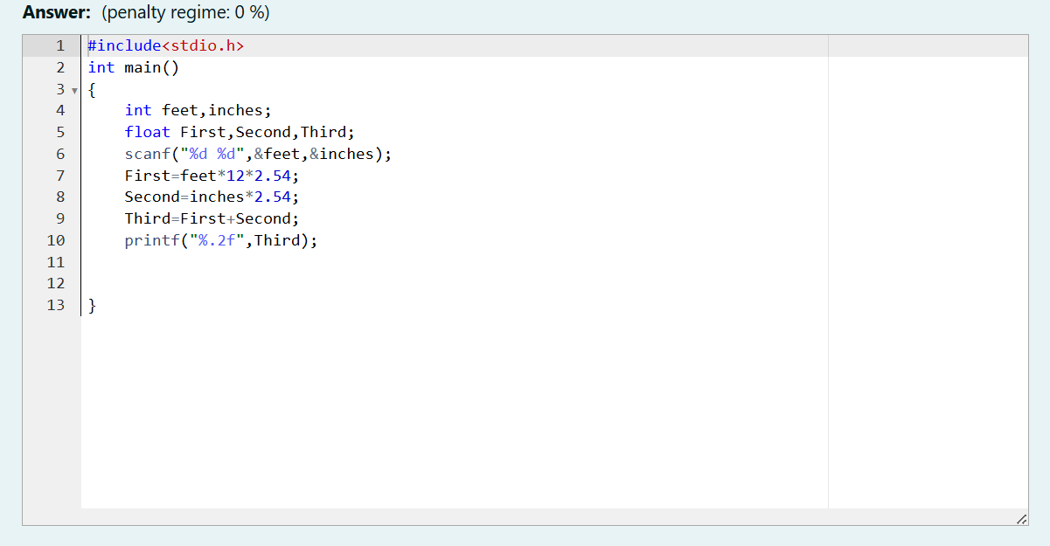

OUTPUT:

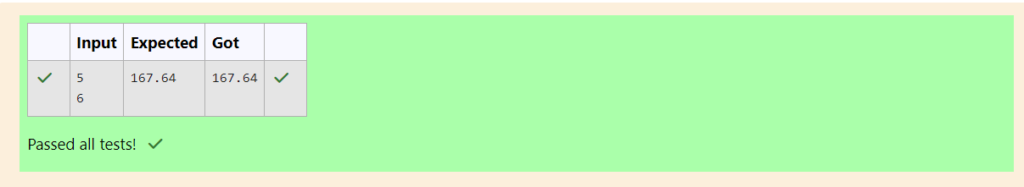

**Q2)** Create a program that reads two integers, a and b, from the user. Your program should

compute and display:

• The sum of a and b

• The difference when b is subtracted from a

• The product of a and b

• The quotient when a is divided by b

• The remainder when a is divided by b

**Input Format**

First line, read the first number.

Second line, read the second number.

**Output Format**

First line, print the sum of a and b

Second line, print the difference when b is subtracted from a

Third line, print the product of a and b

Fourth line, print the quotient when a is divided by b

Fifth line, print the remainder when a is divided by b

**Sample Input 1**

100

6

**Sample Output1**

106

94

600

16

4

Code:

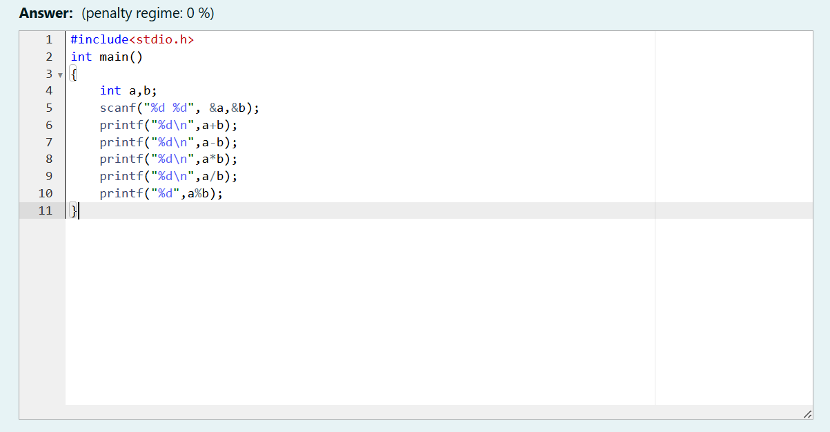

OUTPUT:

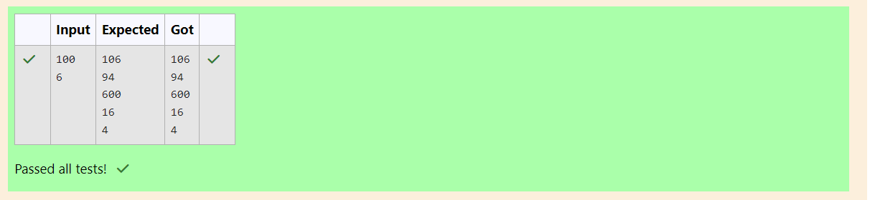

**Q3)** A bakery sells loaves of bread for $3.49 each. Day old bread is discounted by 60 percent.

Write a program that begins by reading the number of loaves of day-old bread being

purchased from the user. Then your program should display the regular price for the

bread, the discount because it is a day old, and the total price. Each of these amounts

should be displayed on its own line with an appropriate label. All of the values should be

displayed using two decimal places.

**Input Format**

Read the number of day old loaves.

**Output Format**

First line, print Regular price: price Second line, print Discount: discount Third line, print

Total: total

Note: All of the values should be displayed using two decimal places.

**Sample Input 1**

10

**Sample Output 1**

Regular price: 34.90 Discount: 20.94 Total: 13.96

**Code:**

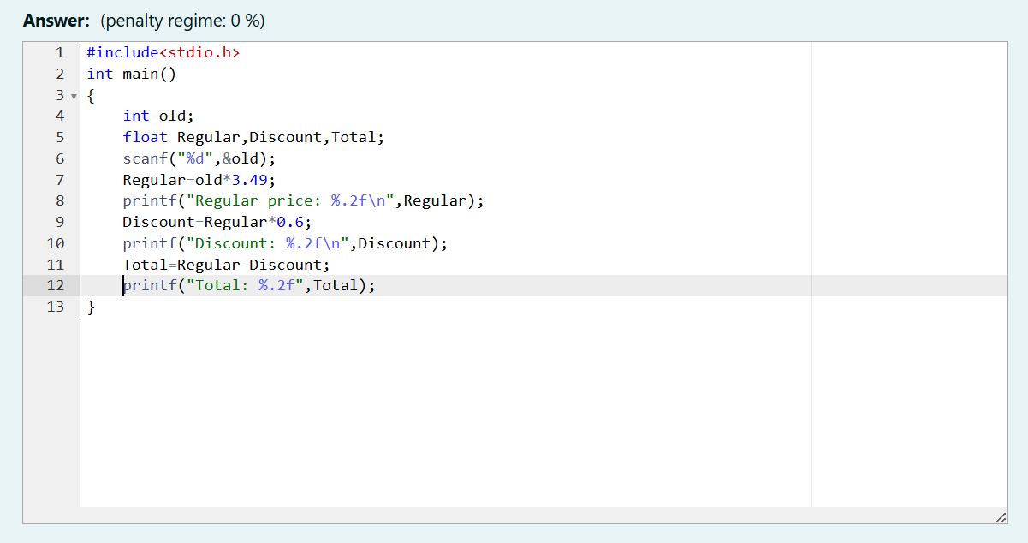

OUTPUT:

